NAME: Saimeera D
REGISTER NO: 192524405
COURSE CODE:CSA1515
COURSE NAME: Cloud Computing And Big Data

Virtualization Practical Record – VMware Workstation
Course: Cloud Computing and Big Data Analytics
You can perform all five practicals using VMware Workstation on your Windows laptop. I'll explain each experiment step by step, including the aim, requirements, procedure, and result for your practical record.
Practical 12: Install a Type-2 Hypervisor and Create a Virtual Machine
Aim
To demonstrate virtualization by installing a Type-2 hypervisor and creating a virtual machine with a guest operating system.
Software Required
- Host OS: Windows 10/11
- Type-2 Hypervisor: VMware Workstation Pro
- Guest OS: Ubuntu Linux or Windows
- RAM: 8 GB or more recommended
- Free disk space: At least 25–30 GB for a comfortable Ubuntu VM setup
Procedure
Step 1: Download VMware Workstation
- Open your browser.
- Visit the official VMware page: VMware Workstation
- Download VMware Workstation for Windows.
- Run the installer.
- Follow the installation instructions.
- Restart your computer if prompted.
Step 2: Download Ubuntu ISO
- Visit Ubuntu Desktop Downloads.
- Download the Ubuntu Desktop ISO file.
- Save it in your Downloads folder.
Step 3: Create a Virtual Machine
- Open VMware Workstation.
- Click Create a New Virtual Machine.
- Select Typical (recommended).
- Click Next.
- Select Installer disc image file (ISO).
- Browse and select the downloaded Ubuntu ISO file.
- Click Next.
- Select Linux as the guest operating system.
- Choose Ubuntu 64-bit.
- Enter a virtual machine name, such as Ubuntu-VM.
- Choose a location to save the VM.
- Complete the wizard and start the VM.
- Follow the Ubuntu installation instructions.
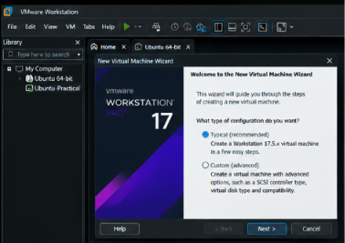

Result
A Type-2 hypervisor was installed successfully, and a virtual machine was created to run Ubuntu Linux on the Windows host operating system.

Practical 13: Create a Virtual Machine with 1 CPU, 2 GB RAM, and 15 GB Storage
Aim
To create and configure a virtual machine with one virtual CPU, 2 GB RAM, and a 15 GB virtual hard disk using Type-2 virtualization software.
Procedure
Step 1: Open VMware Workstation
- Launch VMware Workstation.
- Click Create a New Virtual Machine.
- Select Typical or Custom.
- Click Next.
Step 2: Select the Guest OS
- Choose the Ubuntu ISO file or select the installer later.
- Select Linux.
- Choose Ubuntu 64-bit.
- Click Next.
Step 3: Configure the Virtual Machine
- Enter the name Ubuntu-Practical.
- Select the storage location.
- Set the virtual hard disk size to 15 GB.
- Choose whether to store the disk as a single file or split it into multiple files.
- Click Customize Hardware.
Configure the hardware as follows:
Hardware Component | Configuration
Virtual CPU | 1 processor core
Memory | 2 GB (2048 MB)
Hard Disk | 15 GB
Network Adapter | NAT
CD/DVD | Ubuntu ISO file
- Click Close.
- Click Finish.
- Power on the VM.
Step 4: Test the VM
- Confirm that the virtual machine powers on.
- Install the guest operating system if it has not already been installed.
- Verify that the guest OS runs successfully.
Note: A 2 GB RAM VM can be restrictive for a modern Ubuntu Desktop installation. If installation or operation is too slow, use a lightweight Linux distribution or temporarily allocate more RAM during installation, then restore the required configuration for the practical demonstration.
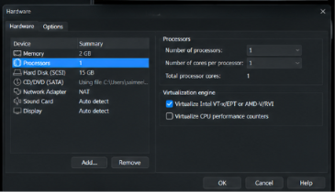
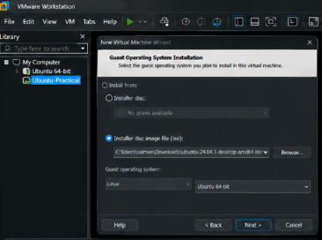
Result
A virtual machine was created with one virtual CPU, 2 GB RAM, and a 15 GB virtual hard disk.

Practical 14: Create a Virtual Hard Disk and Allocate Storage Using VMware Workstation
Aim
To create a virtual hard disk and allocate storage to a virtual machine using VMware Workstation.
Procedure
Step 1: Open the Virtual Machine Settings
- Open VMware Workstation.
- Select your virtual machine.
- Ensure the VM is powered off.
- Click Edit virtual machine settings.
Step 2: Create a Virtual Hard Disk
- Open the Hardware tab.
- Click Add.
- Select Hard Disk.
- Click Next.
- Select the recommended virtual disk type.
- Click Next.
Step 3: Select Disk Type
- Select SCSI if offered as the recommended disk type.
- Click Next.
Step 4: Specify Disk Capacity
- Enter the required disk size, such as 15 GB.
- Select Store virtual disk as a single file or Split virtual disk into multiple files.
- Click Next.
Step 5: Save the Disk
- Enter the virtual disk filename.
- Click Finish.
- Click OK to save the VM settings.
Verification
- Select the VM.
- Open Edit virtual machine settings.
- Check the Hard Disk entry and its configured capacity.
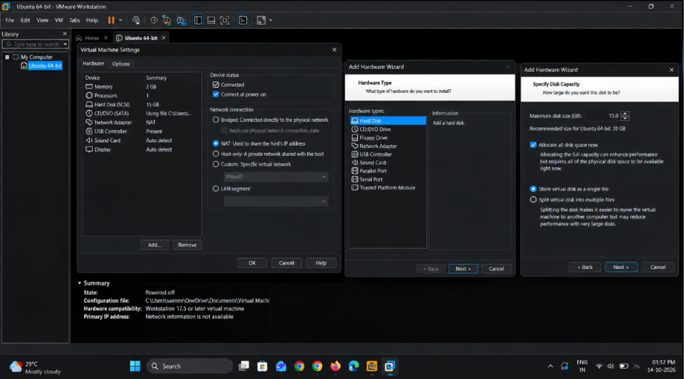
Important: VMware's configured virtual disk capacity is not necessarily the same as the physical disk space occupied on the host. A dynamically growing disk can start small and expand as data is written.
If your VM already has a 15 GB disk from Practical 13, you can either verify that disk or add another virtual disk for this experiment. Adding another disk increases the VM's total configured storage.
Result
A virtual hard disk was created and configured successfully using VMware Workstation.

Practical 15: Create a Snapshot and Restore a Previous Version of a VM
Aim
To create a snapshot of a virtual machine and test the restoration of its previous state.
What Is a Snapshot?
A snapshot records the state of a virtual machine at a particular point in time. It can help you return to an earlier state after making changes.
Procedure
Step 1: Start the Virtual Machine
- Open VMware Workstation.
- Select your Ubuntu virtual machine.
- Click Power on this virtual machine.
- Wait for the guest OS to start.
Step 2: Create a Snapshot
- Open the VM menu.
- Select Snapshot.
- Click Take Snapshot.
- Enter the snapshot name:
Before_Changes
- Enter a description, such as:
Snapshot created before modifying the guest OS.
- Click Take Snapshot.
Step 3: Modify the Virtual Machine
- Open the guest OS.
- Create a test folder named TestFolder.
- Create a text file inside the folder.
- Save the changes.
Step 4: Restore the Snapshot
- Shut down the guest OS if appropriate.
- In VMware Workstation, open the VM menu.
- Select Snapshot.
- Open Snapshot Manager.
- Select Before_Changes.
- Click Go To or the equivalent restore option.
- Confirm the operation if prompted.
- Start the virtual machine again.
Step 5: Verify the Result
- Check whether the test folder and file are absent if they were created only after the snapshot.
- Confirm that the VM has returned to its earlier state.
Precaution: Restoring a snapshot discards or rolls back changes made after that snapshot in the affected VM state. Back up any important data first.
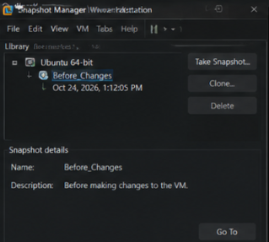
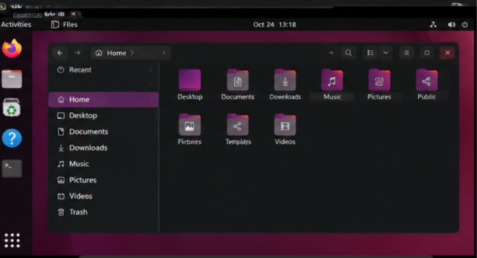
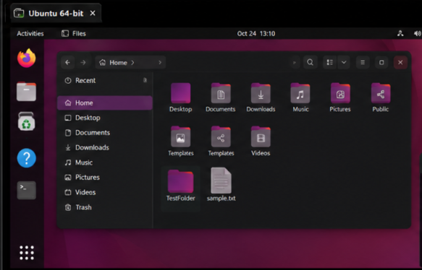
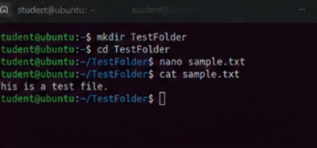
Result
A snapshot was created successfully, and the virtual machine was restored to its previous state.

Practical 16: Clone a Virtual Machine and Test the Cloned VM
Aim
To create a clone of an existing virtual machine and verify that the cloned machine operates independently.
What Is Cloning?
Cloning creates a separate copy of an existing virtual machine, including its virtual disk and configuration.
VMware Workstation versions may offer Full Clone and Linked Clone options.
- Full Clone: An independent copy that does not depend on the original VM's virtual disks.
- Linked Clone: Uses the original VM's virtual disks as a base and depends on them.
A full clone is preferable when you want to test an independent copy.
Procedure
Step 1: Prepare the Original VM
- Open VMware Workstation.
- Select your Ubuntu virtual machine.
- Shut down the guest OS completely.
Step 2: Open the Clone Wizard
- Select the original VM.
- Open the VM menu.
- Select Manage.
- Click Clone, if available.
Depending on your VMware Workstation version, the cloning option may be accessed through the VM's context menu.
Step 3: Select the Clone Source
- Select the current state of the virtual machine or an existing snapshot.
- Click Next.
Step 4: Select Clone Type
- Choose Create a full clone.
- Click Next.
Step 5: Name the Clone
Enter a name such as:
Ubuntu-Clone
Choose a separate storage location and complete the wizard.
Step 6: Start the Cloned VM
- Select Ubuntu-Clone.
- Click Power on this virtual machine.
- If VMware asks whether the VM was moved or copied, choose I Copied It for a newly created independent clone, unless your specific workflow requires otherwise.
Step 7: Test the Clone
- Log in to the cloned operating system.
- Create a test file named clone_test.txt.
- Save the file.
- Shut down the cloned VM.
- Start the original VM.
- Check whether clone_test.txt exists in the original VM.
If you created the file only in the clone, it should not appear in the original VM.
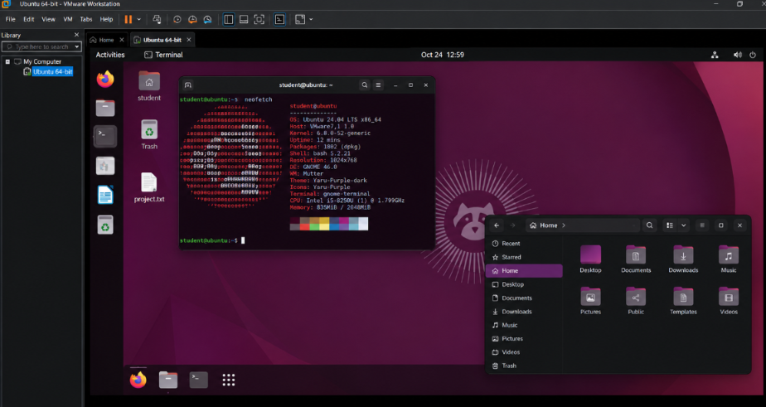
Result
A cloned virtual machine was created successfully and tested independently of the original virtual machine.

